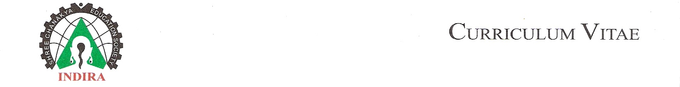
UJWAL V. SALVE

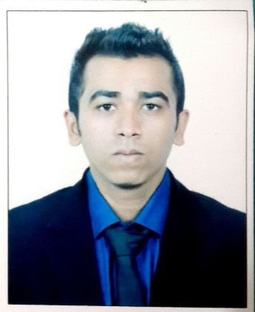

13, Aditya Appt, Sukhakarta colony B,
Vivekanand Nagar, Kala Khadak,
Wakad – 411057
Mobile : 091-9975084332,

E-mail: ujwal.salve@indiraiimp.edu.in
ujwalsalve91@gmail.com

Specialization: MBA Finance

CAREER OBJECTIVE:

Looking for a challenging career which demands the best of my professional ability in terms of, technical and analytical skills, and helps me in broadening and enhancing my current skill and knowledge.

Education:

MBA Indira Institute of Pune University 2013-2015 53%
(Finance) Management, Pune

B.com B.Y.K, Nashik Pune University 2009-2013 54%

H.S.C Bytco College of Science, Nasik Board 2008 41%
Nashik Road

S.S.C P.E. School Nashik Nasik Board 2005 60.13%

Project Details:

MBA (Finance)

Project Title: “Financial Analysis of Gemini International Pvt. Ltd.”

Duration: 2 months

Details:
- To compare and analyze financial statements of past 3 financial years.
- To know the profitability, liquidity and solvency position of Gemini International.
- To forecast annual growth rate of income of the company with help of regression analysis.

B.Com

Project Title: “Role of Bank of Baroda Rural Development”

Details:

- To analyse various scheme provided by the bank of Baroda for rural citizen.
- To generate awareness about the new schemes of Bank among the rural citizen.
- To analyse how the schemes will be helpful for the people.

Additional Qualification:

- Undertook Training on the following Managerial Skills:-
- Problem Solving
- Negotiation

Computer Skills:

Packages Known: MS Office (Word, PowerPoint, Excel, MS Access).

Extra-Curricular Activities

- Compose music in FL studio
- Teaching Guitar to children in primary school.
- Socially contributed to SES NGO, Pune.
- Played football representing BYK College.
- Gym Trainer at Nashik Grow Up Gym
- Played from cricket from NDCA under 17 team.

Personal Details:

Date of Birth: 13/06/1990
Marital Status: Single
Strengths:
- Confident.
- Self-Motivated.
- Patient.
- Adaptable.
- Good Grasping power.

Languages: English, Hindi, Marathi, Punjabi.

